**STUDY OF TCP, UDP PERFORMANCE USING NS2**

Ex. No. : 312217205003

Date: P.G. ABINAYA

**PROGRAM:**

**Second.tcl**

set ns [new Simulator]

##### Setting output files

set file [open second.tr w]

$ns trace-all $file

set namfile [open second.nam w]

$ns namtrace-all $namfile

set tcpfile [open second.tcp w]

Agent/TCP set trace_all_oneline_ true

##### Setting Nodes

set n0 [$ns node]

set n1 [$ns node]

set n2 [$ns node]

set n3 [$ns node]

##### Setting Links

$ns duplex-link $n0 $n2 1.5Mb 20ms DropTail

$ns duplex-link $n1 $n2 1.5Mb 20ms DropTail

$ns duplex-link $n2 $n3 1.5Mb 20ms DropTail

$ns duplex-link-op $n0 $n2 orient right-down

$ns duplex-link-op $n1 $n2 orient right-up

$ns duplex-link-op $n2 $n3 orient right

$ns duplex-link-op $n2 $n3 queuePos 0.5

##### Setting Queue Length

$ns queue-limit $n2 $n3 20

##### Setting UDP Agent

set udp [new Agent/UDP]

$ns attach-agent $n0 $udp

set null [new Agent/Null]

$ns attach-agent $n3 $null

$ns connect $udp $null

$udp set fid_ 0

$ns color 0 blue

##### Setting CBR Application

set cbr [new Application/Traffic/CBR]

$cbr attach-agent $udp

##### Setting TCP Agent

set tcp [new Agent/TCP]

$ns attach-agent $n1 $tcp

set sink [new Agent/TCPSink]

$ns attach-agent $n3 $sink

$ns connect $tcp $sink

$tcp set fid_ 2

$ns color 2 yellow

### Setting output file of TCP Agent#

$tcp attach-trace $tcpfile

$tcp trace cwnd_

##### Setting FTP Application

set ftp [new Application/FTP]

$ftp attach-agent $tcp

##### Setting time schedule of simulation

$ns at 1.0 "$cbr start"

$ns at 2.0 "$cbr stop"

$ns at 2.0 "$ftp start"

$ns at 3.0 "$ftp stop"

$ns at 3.0 "finish"

proc finish {} {

global ns file namfile tcpfile

$ns flush-trace

close $file

close $namfile

close $tcpfile

exit 0

}

##### Finish setting and start simulation

$ns run

**SAMPLE INPUT/OUTPUT:**

**Second.tr**

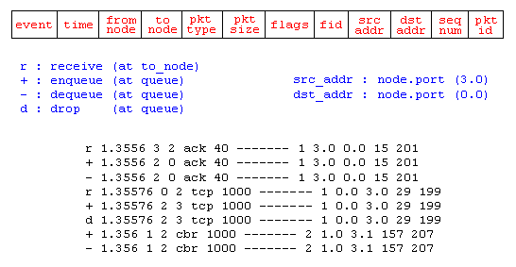

+ 1.01875 0 2 cbr 210 ------- 0 0.0 3.0 5 5

- 1.01875 0 2 cbr 210 ------- 0 0.0 3.0 5 5

r 1.02112 0 2 cbr 210 ------- 0 0.0 3.0 0 0

+ 1.02112 2 3 cbr 210 ------- 0 0.0 3.0 0 0

- 1.02112 2 3 cbr 210 ------- 0 0.0 3.0 0 0

r 2.040427 2 3 tcp 40 ------- 2 1.0 3.1 0 267

+ 2.040427 3 2 ack 40 ------- 2 3.1 1.0 0 268

- 2.040427 3 2 ack 40 ------- 2 3.1 1.0 0 268

r 2.06064 3 2 ack 40 ------- 2 3.1 1.0 0 268

**Second.tcp**

time: 0.00000 saddr: 1 sport: 0 daddr: 3 dport: 1 maxseq: -1 hiack: -1 seqno: 0 cwnd: 1.000 ssthresh: 20 dupacks: 0 rtt: 0.000 srtt: 0.000 rttvar: 12.000 bkoff: 1

time: 2.08085 saddr: 1 sport: 0 daddr: 3 dport: 1 maxseq: 0 hiack: 0 seqno: 1 cwnd: 2.000 ssthresh: 20 dupacks: 0 rtt: 0.080 srtt: 0.080 rttvar: 0.040 bkoff: 1

time: 2.17237 saddr: 1 sport: 0 daddr: 3 dport: 1 maxseq: 2 hiack: 1 seqno: 3 cwnd: 3.000 ssthresh: 20 dupacks: 0 rtt: 0.090 srtt: 0.080 rttvar: 0.033 bkoff: 1

time: 2.17792 saddr: 1 sport: 0 daddr: 3 dport: 1 maxseq: 4 hiack: 2 seqno: 5 cwnd: 4.000 ssthresh: 20 dupacks: 0 rtt: 0.090 srtt: 0.080 rttvar: 0.033 bkoff: 1

time: 2.26389 saddr: 1 sport: 0 daddr: 3 dport: 1 maxseq: 6 hiack: 3 seqno: 7 cwnd: 5.000 ssthresh: 20 dupacks: 0 rtt: 0.090 srtt: 0.080 rttvar: 0.028 bkoff: 1

**UDP:**

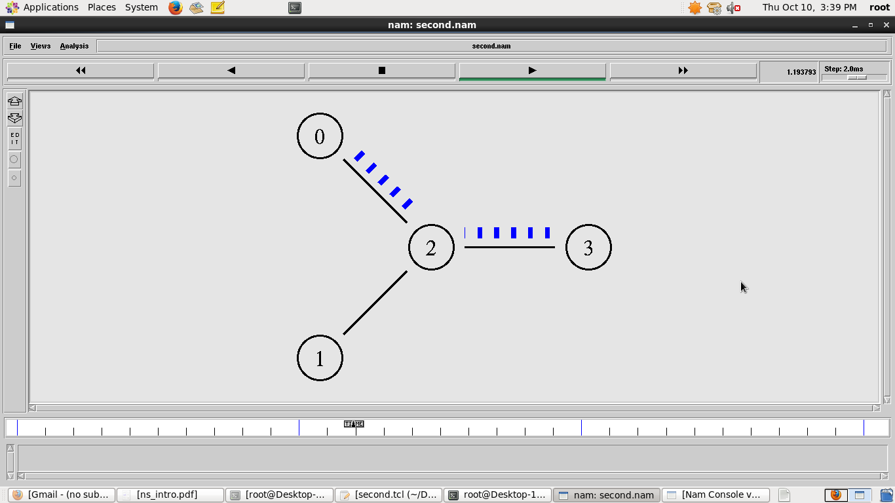

**TCP:**

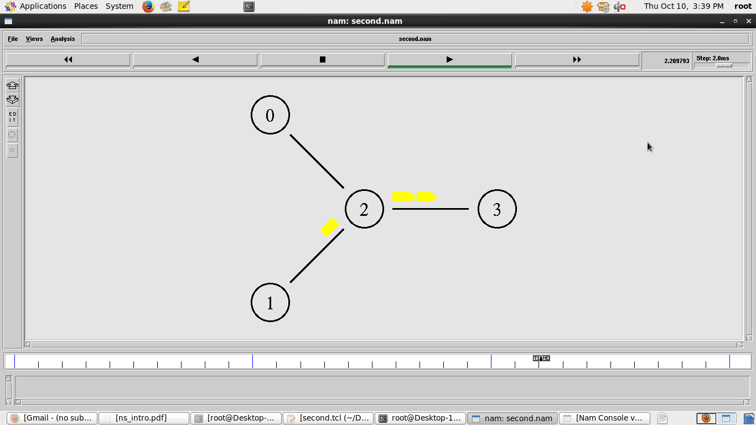

**SIMULATION OF CONGESTION CONTROL ALGORITHM USING NS2**

Ex. No. : 312217205003

Date: P.G. ABINAYA

**PROGRAM:**

**Second.tcl:**

set ns [new Simulator]

##### Setting output files

set file [open second.tr w]

$ns trace-all $file

set namfile [open second.nam w]

$ns namtrace-all $namfile

set tcpfile [open second.tcp w]

Agent/TCP set trace_all_oneline_ true

##### Setting Nodes

set n0 [$ns node]

set n1 [$ns node]

set n2 [$ns node]

set n3 [$ns node]

##### Setting Links

$ns duplex-link $n0 $n2 1.5Mb 20ms DropTail

$ns duplex-link $n1 $n2 1.5Mb 20ms DropTail

$ns duplex-link $n2 $n3 1.5Mb 10ms DropTail

$ns duplex-link-op $n0 $n2 orient right-down

$ns duplex-link-op $n1 $n2 orient right-up

$ns duplex-link-op $n2 $n3 orient right

$ns duplex-link-op $n2 $n3 queuePos 0.5

##### Setting Queue Length

#$ns queue-limit $n2 $n3 2

##### Setting UDP Agent

set udp [new Agent/UDP]

$ns attach-agent $n0 $udp

set null [new Agent/Null]

$ns attach-agent $n3 $null

$ns connect $udp $null

$udp set fid_ 0

$ns color 0 blue

##### Setting CBR Application

set cbr [new Application/Traffic/CBR]

$cbr attach-agent $udp

$cbr set type_ CBR

$cbr set packet_size_ 10

$cbr set rate_ 0.01mb

#$cbr set random_ false

##### Setting TCP Agent

set tcp [new Agent/TCP]

$ns attach-agent $n1 $tcp

set sink [new Agent/TCPSink]

$ns attach-agent $n3 $sink

$ns connect $tcp $sink

$tcp set fid_ 2

$tcp set window_ 2000

$tcp set packetSize_ 200

$ns color 2 yellow

### Setting output file of TCP Agent#

$tcp attach-trace $tcpfile

$tcp trace cwnd_

##### Setting FTP Application

set ftp [new Application/FTP]

$ftp attach-agent $tcp

##### Setting time schedule of simulation

$ns at 1.0 "$cbr start"

$ns at 1.5 "$ftp start"

$ns at 2.0 "$cbr stop"

$ns at 3.0 "$ftp stop"

$ns at 3.0 "finish"

proc finish {} {

global ns file namfile tcpfile

$ns flush-trace

close $file

close $namfile

close $tcpfile

exec nam second.nam &

exit 0

}

##### Finish setting and start simulation

$ns run

**SAMPLE INPUT/OUTPUT:**

**Second.tr:**



+ 1.048 0 2 cbr 10 ------- 0 0.0 3.0 6 6

- 1.048 0 2 cbr 10 ------- 0 0.0 3.0 6 6

r 1.052053 0 2 cbr 10 ------- 0 0.0 3.0 4 4

**second.tcp:**

time: 0.00000 saddr: 1 sport: 0 daddr: 3 dport: 1 maxseq: -1 hiack: -1 seqno: 0 cwnd: 1.000 ssthresh: 20 dupacks: 0 rtt: 0.000 srtt: 0.000 rttvar: 12.000 bkoff: 1

time: 1.56085 saddr: 1 sport: 0 daddr: 3 dport: 1 maxseq: 0 hiack: 0 seqno: 1 cwnd: 2.000 ssthresh: 2000 dupacks: 0 rtt: 0.060 srtt: 0.060 rttvar: 0.030 bkoff: 1

time: 1.62384 saddr: 1 sport: 0 daddr: 3 dport: 1 maxseq: 2 hiack: 1 seqno: 3 cwnd: 3.000 ssthresh: 2000 dupacks: 0 rtt: 0.060 srtt: 0.060 rttvar: 0.022 bkoff: 1

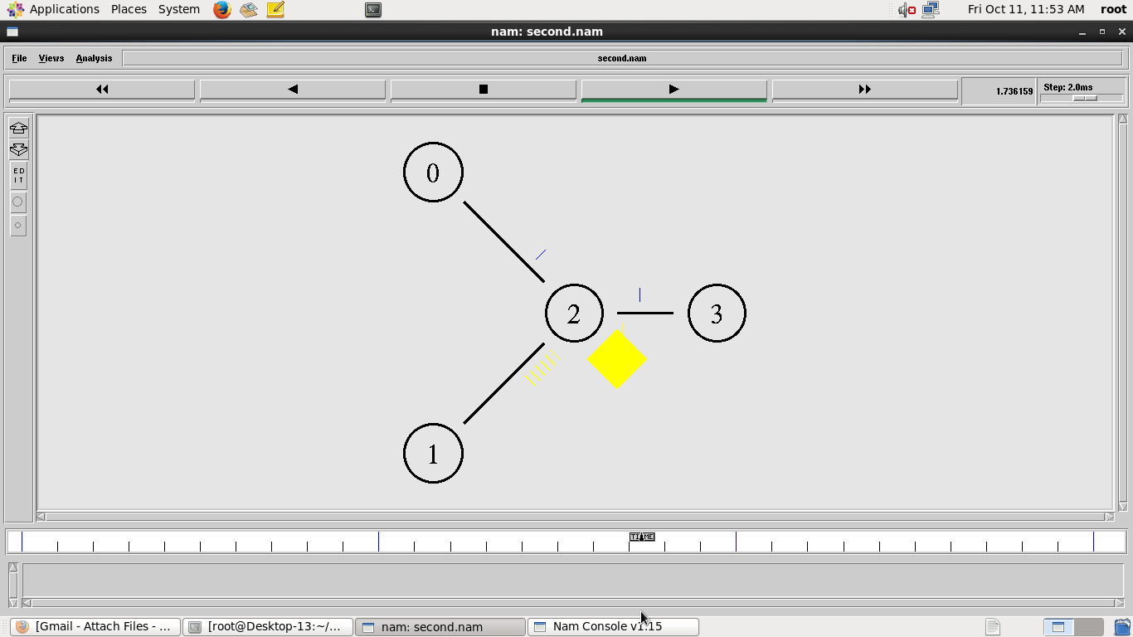

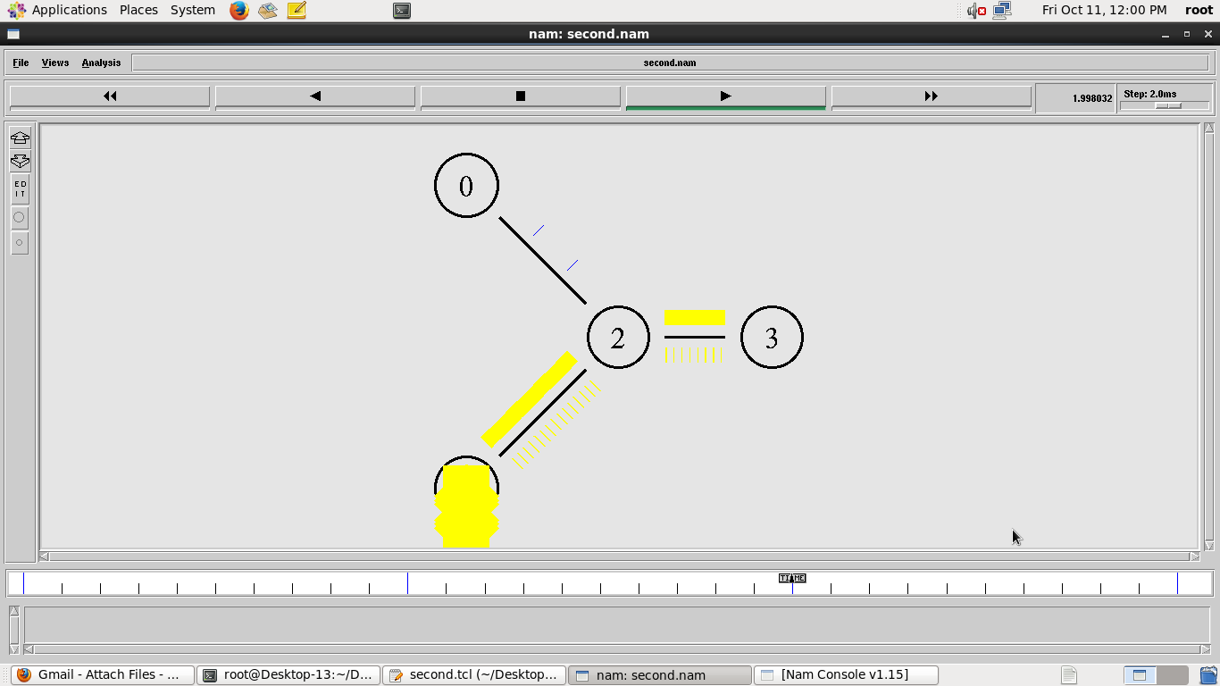

**SIMULATION OF DISTANCE VECTOR AND LINK STATE ROUTING ALGORITHM**

Ex. No. : 312217205003

Date: P.G. ABINAYA

**PROGRAM(DISTANCE VECTOR):**

**Dist.tcl:**

set ns [new Simulator]

set nr [open dist.tr w]

$ns trace-all $nr

set nf [open dist.nam w]

$ns namtrace-all $nf

proc finish {} {

global ns nr nf

$ns flush-trace

close $nf

close $nr

exec nam dist.nam &

exit 0

}

for { set i 0 } { $i < 5} { incr i 1 } { set n($i) [$ns node]}

for {set i 0} {$i < 2} {incr i} {

$ns duplex-link $n($i) $n([expr $i+1]) 1Mb 10ms DropTail}

$ns duplex-link $n(0) $n(3) 1Mb 10ms DropTail

$ns duplex-link $n(1) $n(4) 1Mb 10ms DropTail

$ns duplex-link $n(0) $n(2) 1Mb 10ms DropTail

$ns duplex-link $n(2) $n(4) 1Mb 10ms DropTail

$ns duplex-link-op $n(0) $n(3) orient down

$ns duplex-link-op $n(0) $n(1) orient right-down

$ns duplex-link-op $n(1) $n(4) orient down

$ns duplex-link-op $n(0) $n(2) orient 180deg

$ns duplex-link-op $n(2) $n(4) orient right-up

$ns duplex-link-op $n(2) $n(4) orient right-down

set udp0 [new Agent/UDP]

$ns attach-agent $n(0) $udp0

set cbr0 [new Application/Traffic/CBR]

$cbr0 set packetSize_ 500

$cbr0 set interval_ 0.005

$cbr0 attach-agent $udp0

set null0 [new Agent/Null]

$ns attach-agent $n(4) $null0

$ns connect $udp0 $null0

set udp1 [new Agent/UDP]

$ns attach-agent $n(1) $udp1

set cbr1 [new Application/Traffic/CBR]

$cbr1 set packetSize_ 500

$cbr1 set interval_ 0.005

$cbr1 attach-agent $udp1

set null0 [new Agent/Null]

$ns attach-agent $n(4) $null0

$ns connect $udp1 $null0

$ns rtproto DV

$ns rtmodel-at 2.0 down $n(1) $n(4)

$ns rtmodel-at 1.5 down $n(0) $n(2)

$ns rtmodel-at 3.0 up $n(0) $n(1)

$ns rtmodel-at 2.0 up $n(0) $n(3)

$udp0 set fid_ 1

$udp1 set fid_ 2

$ns color 1 Red

$ns color 2 Green

$ns at 1.0 "$cbr0 start"

$ns at 2.0 "$cbr1 start"

$ns at 4 "finish"

$ns run

**SAMPLE INPUT/OUTPUT:**

**Dist.tr:**

+ 0.00017 0 1 rtProtoDV 5 ------- 0 0.2 1.2 -1 0

- 0.00017 0 1 rtProtoDV 5 ------- 0 0.2 1.2 -1 0

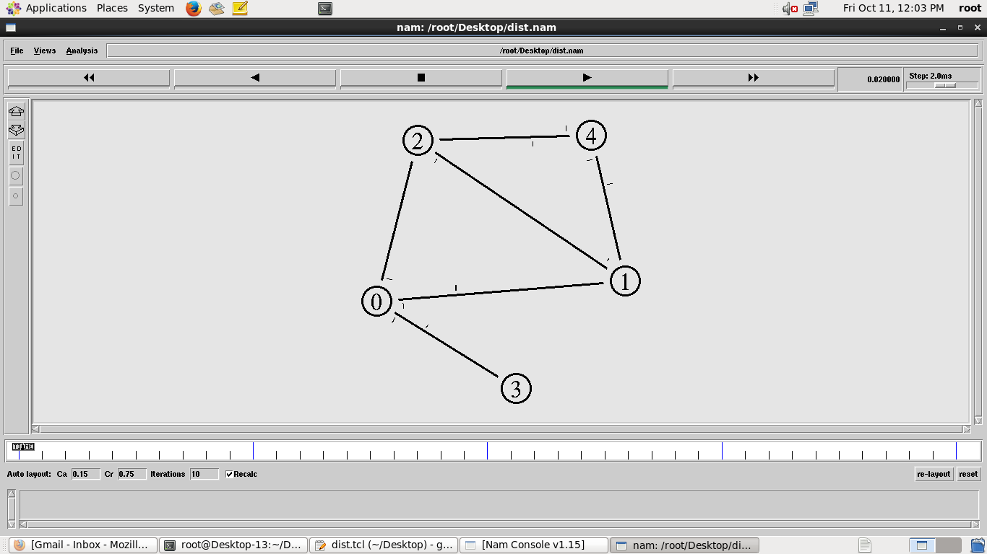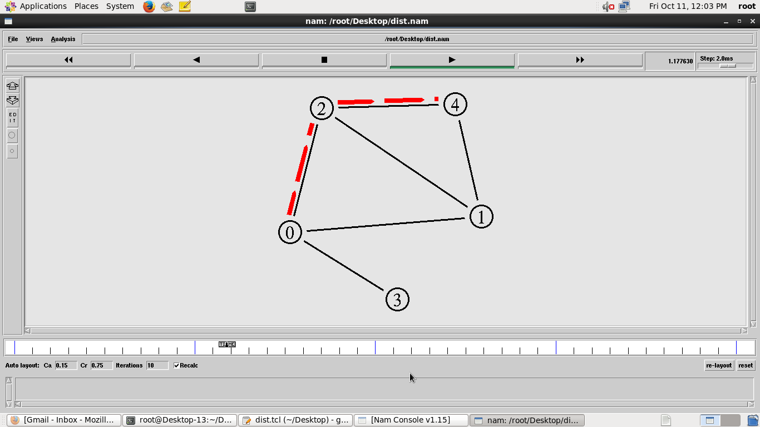

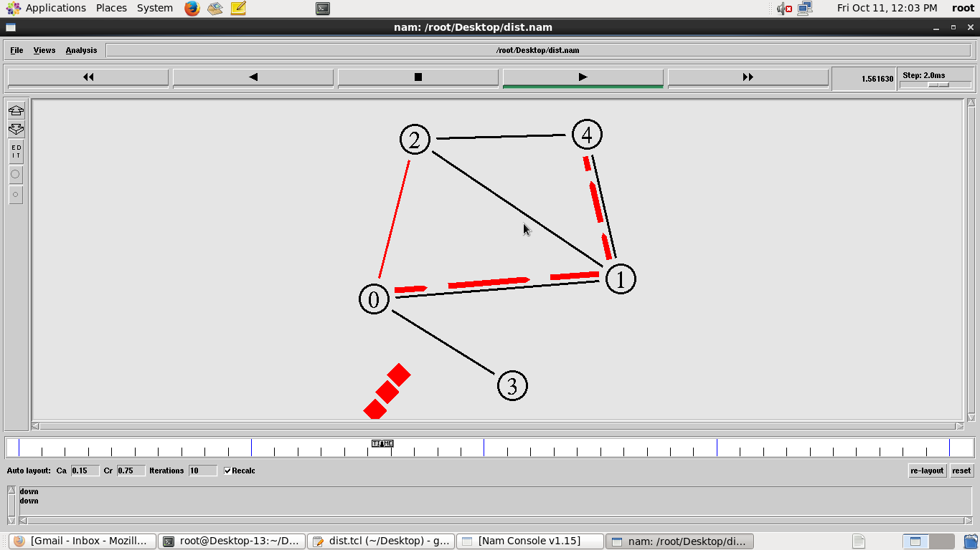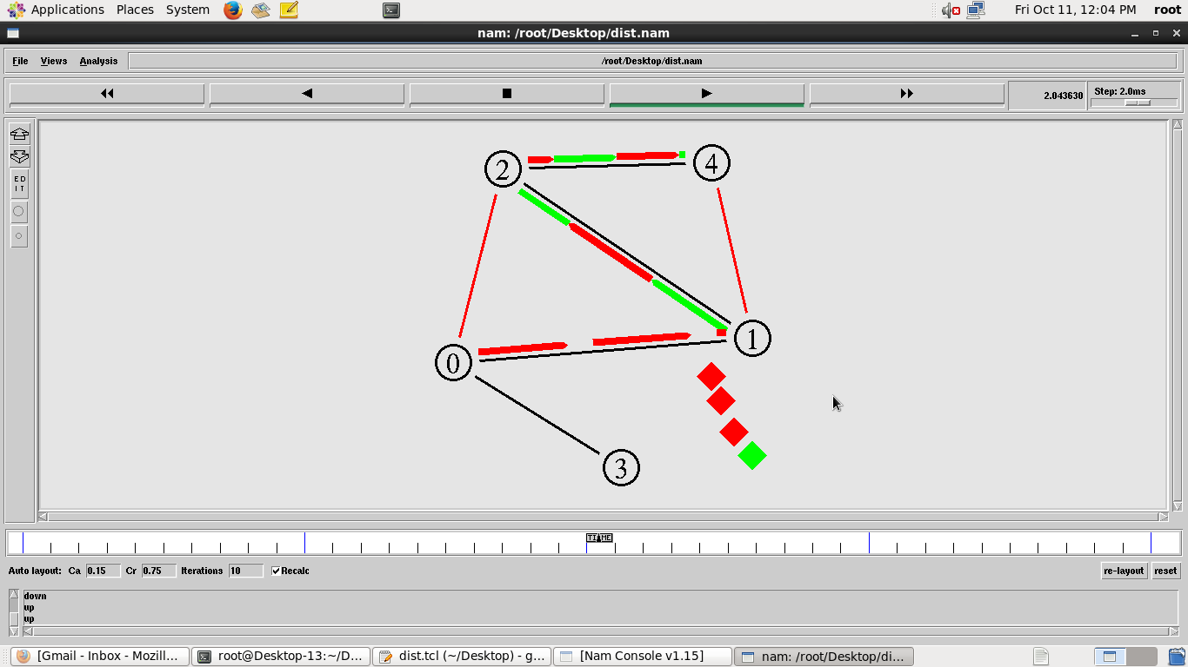

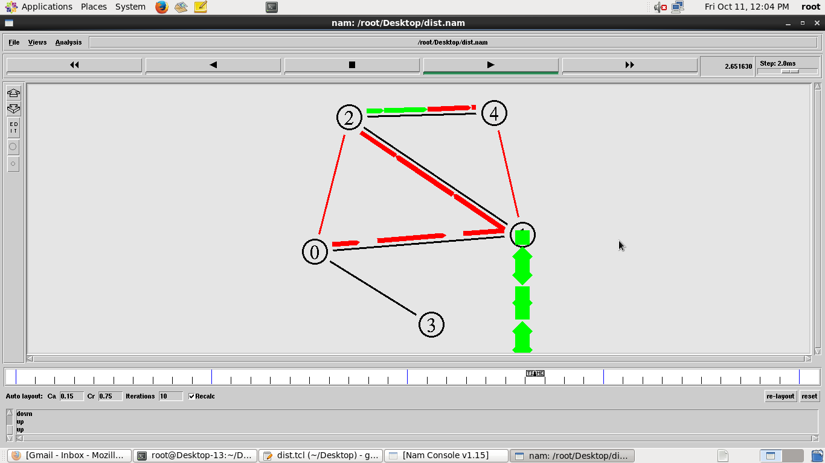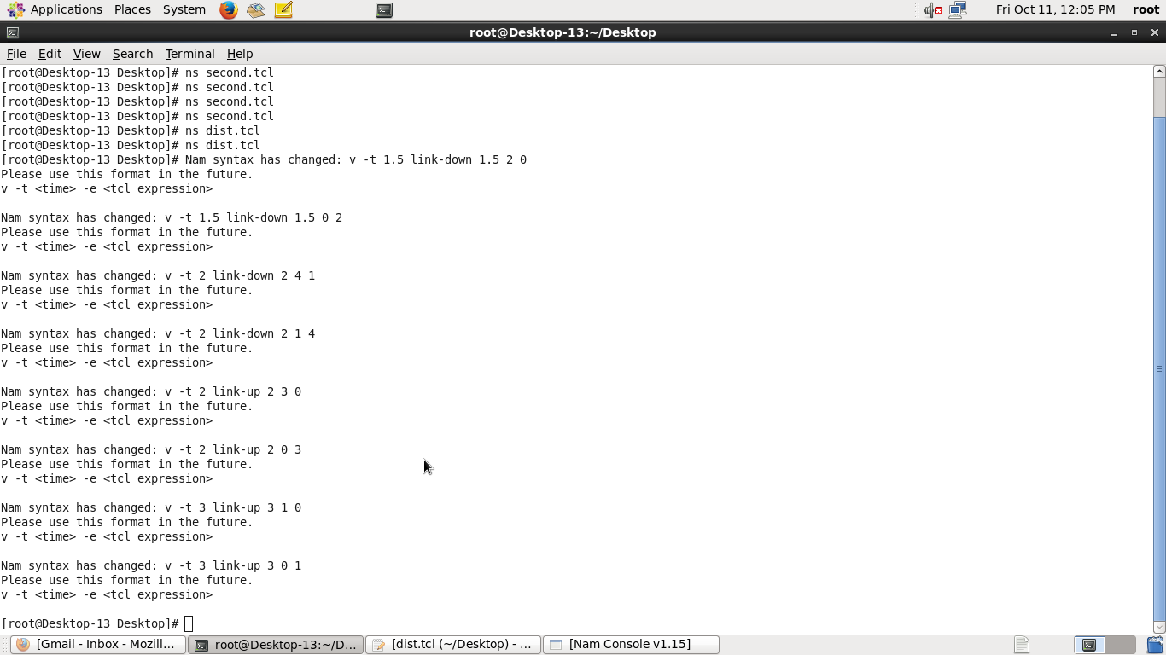

**PROGRAM(LINK STATE):**

set ns [new Simulator]

set nr [open link.tr w]

$ns trace-all $nr

set nf [open link.nam w]

$ns namtrace-all $nf

proc finish {} {

global ns nr nf

$ns flush-trace

close $nf

close $nr

exec nam link.nam &

exit 0

}

for { set i 0 } { $i < 5} { incr i 1 } { set n($i) [$ns node]}

for {set i 0} {$i < 2} {incr i} {

$ns duplex-link $n($i) $n([expr $i+1]) 1Mb 10ms DropTail}

$ns duplex-link $n(0) $n(3) 1Mb 10ms DropTail

$ns duplex-link $n(1) $n(4) 1Mb 10ms DropTail

$ns duplex-link $n(0) $n(2) 1Mb 10ms DropTail

$ns duplex-link $n(2) $n(4) 1Mb 10ms DropTail

$ns duplex-link-op $n(0) $n(3) orient down

$ns duplex-link-op $n(0) $n(1) orient right-down

$ns duplex-link-op $n(1) $n(4) orient down

$ns duplex-link-op $n(0) $n(2) orient 180deg

$ns duplex-link-op $n(2) $n(4) orient right-up

$ns duplex-link-op $n(2) $n(4) orient right-down

set udp0 [new Agent/UDP]

$ns attach-agent $n(0) $udp0

set cbr0 [new Application/Traffic/CBR]

$cbr0 set packetSize_ 500

$cbr0 set interval_ 0.005

$cbr0 attach-agent $udp0

set null0 [new Agent/Null]

$ns attach-agent $n(4) $null0

$ns connect $udp0 $null0

set udp1 [new Agent/UDP]

$ns attach-agent $n(1) $udp1

set cbr1 [new Application/Traffic/CBR]

$cbr1 set packetSize_ 500

$cbr1 set interval_ 0.005

$cbr1 attach-agent $udp1

set null0 [new Agent/Null]

$ns attach-agent $n(4) $null0

$ns connect $udp1 $null0

$ns rtproto LS

$ns rtmodel-at 2.0 down $n(1) $n(4)

$ns rtmodel-at 1.5 down $n(0) $n(2)

$ns rtmodel-at 3.0 up $n(0) $n(1)

$ns rtmodel-at 2.0 up $n(0) $n(3)

$udp0 set fid_ 1

$udp1 set fid_ 2

$ns color 1 Red

$ns color 2 Green

$ns at 1.0 "$cbr0 start"

$ns at 2.0 "$cbr1 start"

$ns at 4 "finish"

$ns run

**SAMPLE INPUT/OUTPUT:**

**Link.tr:**

+ 0.00017 0 1 rtProtoLS 100 ------- 0 0.2 1.2 -1 0

- 0.00017 0 1 rtProtoLS 100 ------- 0 0.2 1.2 -1 0

+ 0.00017 0 2 rtProtoLS 100 ------- 0 0.2 2.1 -1 1

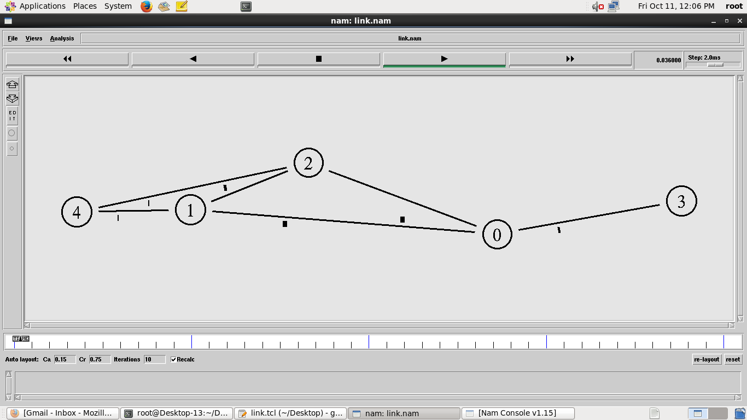 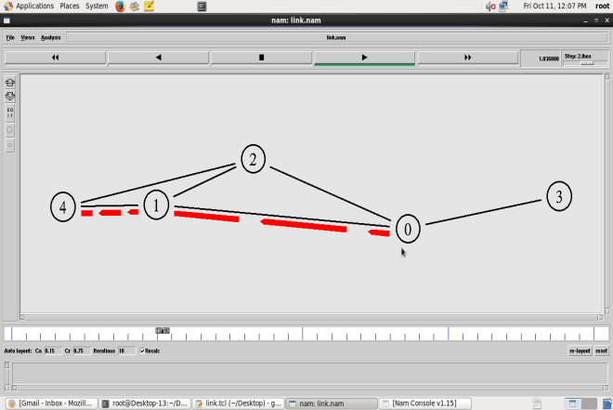

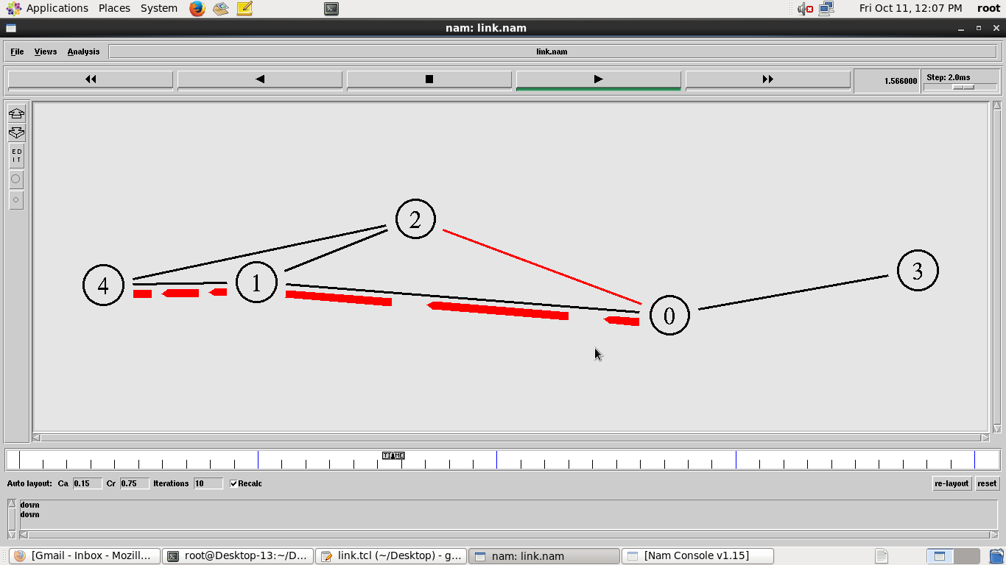 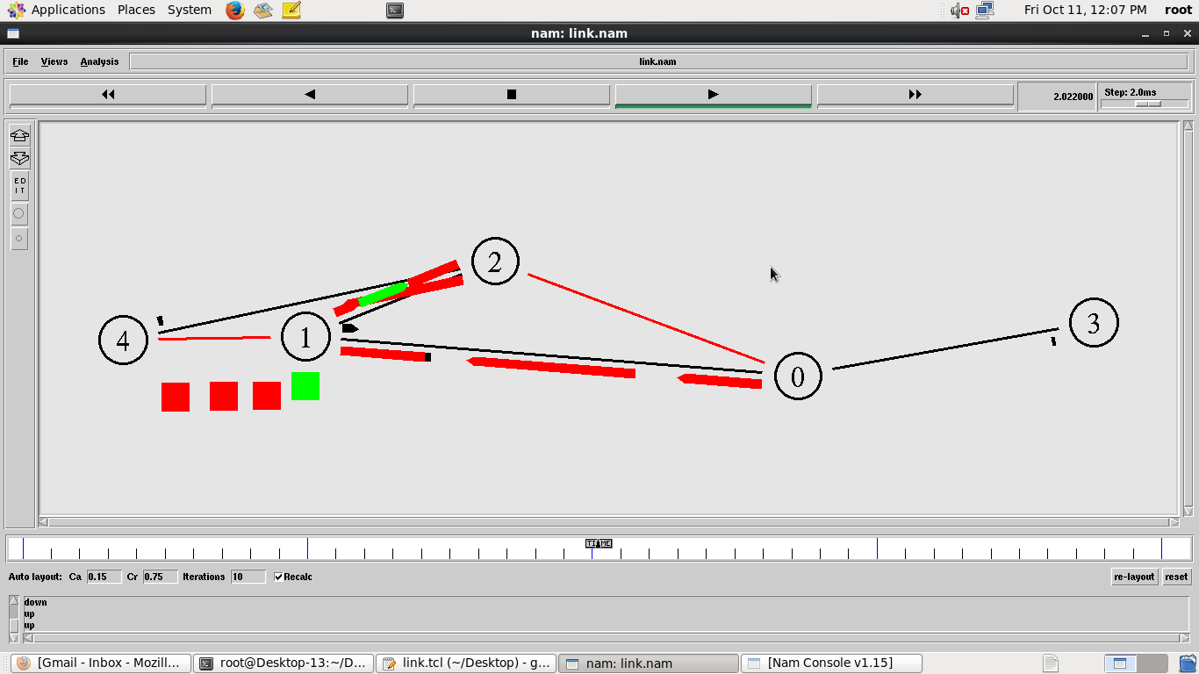

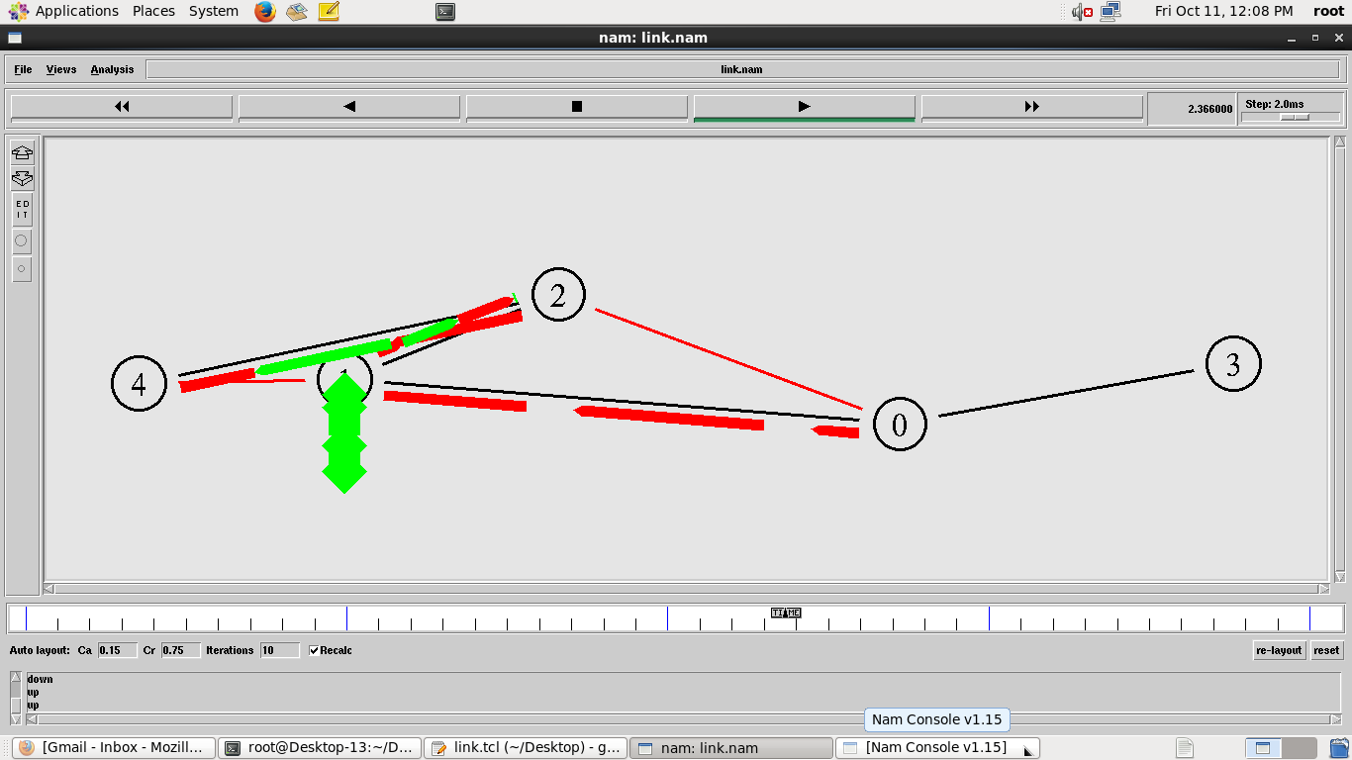 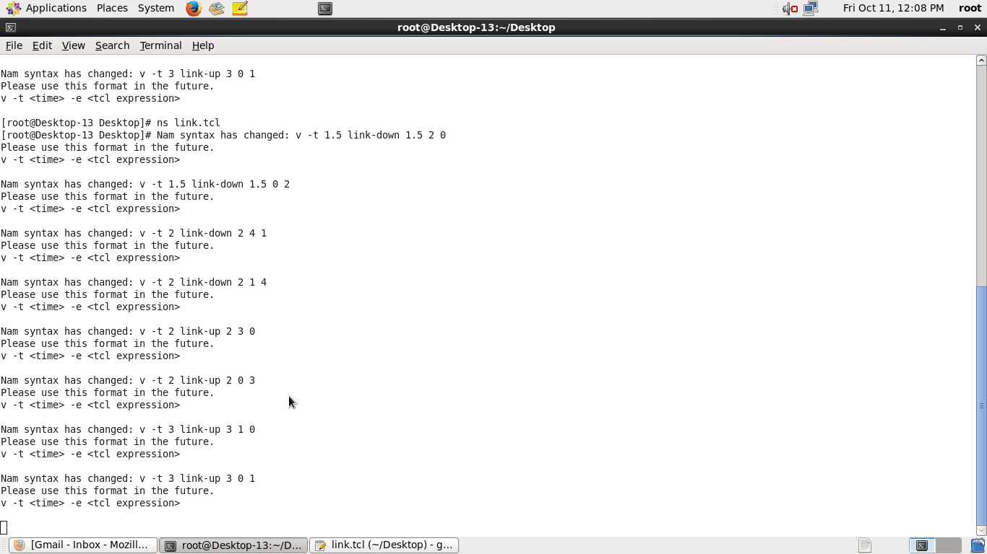

**PERFORMANCE EVALUATION OF ROUTING PROTOCOL USING SIMULATION TOOL**

Ex. No. : 312217205003

Date: P.G. ABINAYA

**PROGRAM:**

**Perfo.tcl:**

#This example is to demonstrate the multicast routing protocol.

set ns [new Simulator -multicast on]

#Turn on Tracing

set tf [open output.tr w]

$ns trace-all $tf

# Turn on nam Tracing

set fd [open mcast.nam w]

$ns namtrace-all $fd

# Create nodes

set n0 [$ns node]

set n1 [$ns node]

set n2 [$ns node]

set n3 [$ns node]

set n4 [$ns node]

set n5 [$ns node]

set n6 [$ns node]

set n7 [$ns node]

# Create links with DropTail Queues

$ns duplex-link $n0 $n2 1.5Mb 10ms DropTail

$ns duplex-link $n1 $n2 1.5Mb 10ms DropTail

$ns duplex-link $n2 $n3 1.5Mb 10ms DropTail

$ns duplex-link $n3 $n4 1.5Mb 10ms DropTail

$ns duplex-link $n3 $n7 1.5Mb 10ms DropTail

$ns duplex-link $n4 $n5 1.5Mb 10ms DropTail

$ns duplex-link $n4 $n6 1.5Mb 10ms DropTail

# Routing protocol: say distance vector

#Protocols: CtrMcast, DM, ST, BST

#Dense Mode protocol is supported in this example

set mproto DM

set mrthandle [$ns mrtproto $mproto {}]

# Set two groups with group addresses

set group1 [Node allocaddr]

set group2 [Node allocaddr]

# UDP Transport agent for the traffic source for group1

set udp0 [new Agent/UDP]

$ns attach-agent $n0 $udp0

$udp0 set dst_addr_ $group1

$udp0 set dst_port_ 0

set cbr1 [new Application/Traffic/CBR]

$cbr1 attach-agent $udp0

# Transport agent for the traffic source for group2

set udp1 [new Agent/UDP]

$ns attach-agent $n1 $udp1

$udp1 set dst_addr_ $group2

$udp1 set dst_port_ 0

set cbr2 [new Application/Traffic/CBR]

$cbr2 attach-agent $udp1

# Create receiver to accept the packets

set rcvr1 [new Agent/Null]

$ns attach-agent $n5 $rcvr1

$ns at 1.0 "$n5 join-group $rcvr1 $group1"

set rcvr2 [new Agent/Null]

$ns attach-agent $n6 $rcvr2

$ns at 1.5 "$n6 join-group $rcvr2 $group1"

set rcvr3 [new Agent/Null]

$ns attach-agent $n7 $rcvr3

$ns at 2.0 "$n7 join-group $rcvr3 $group1"

set rcvr4 [new Agent/Null]

$ns attach-agent $n5 $rcvr4

$ns at 2.5 "$n5 join-group $rcvr4 $group2"

set rcvr5 [new Agent/Null]

$ns attach-agent $n6 $rcvr5

$ns at 3.0 "$n6 join-group $rcvr5 $group2"

set rcvr6 [new Agent/Null]

$ns attach-agent $n7 $rcvr6

#The nodes are leaving the group at specified times

$ns at 3.5 "$n7 join-group $rcvr6 $group2"

$ns at 4.0 "$n5 leave-group $rcvr1 $group1"

$ns at 4.5 "$n6 leave-group $rcvr2 $group1"

$ns at 5.0 "$n7 leave-group $rcvr3 $group1"

$ns at 5.5 "$n5 leave-group $rcvr4 $group2"

$ns at 6.0 "$n6 leave-group $rcvr5 $group2"

$ns at 6.5 "$n7 leave-group $rcvr6 $group2"

# Schedule events

$ns at 0.5 "$cbr1 start"

$ns at 9.5 "$cbr1 stop"

$ns at 4.5 "$cbr2 start"

$ns at 9.5 "$cbr2 stop"

#post-processing

$ns at 10.0 "finish"

proc finish {} {

global ns tf

$ns flush-trace

close $tf

exec nam mcast.nam &

exit 0

}

$ns set-animation-rate 3.0ms

$ns run

**SAMPLE INPUT/OUTPUT:**

**Output.tr:**

+ 9.24125 0 2 cbr 210 ------- 0 0.1 1073741824.0 2331 4262

- 9.24125 0 2 cbr 210 ------- 0 0.1 1073741824.0 2331 4262

r 9.243917 1 2 prune 80 ------- 30 1.0 2.0 -1 4253

r 9.24461 3 7 cbr 210 ------- 0 0.1 1073741824.0 2323 4239

